**Chapter 13 - GRACE UPSHAW & LARINA TAVO**

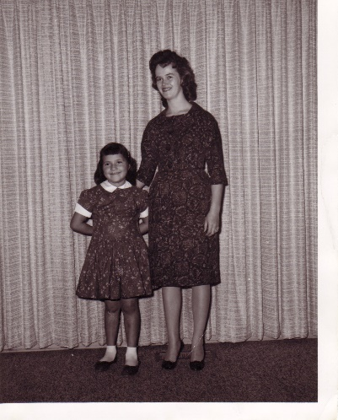When Sandi was about two years old, the church was asking for families to take in Indian children on the "Indian Placement Program". They announced it in our ward several times and finally Ken & I decided to take one in. We were late calling in, but they called us back saying they had an 8-year-old girl named **Grace Upshaw** who would be coming to live with us for the school year. When we went to the stake center in Provo to pick up the child, (they had come in on buses and had to go through a screening - hygiene, vaccination shots, checked for head lice, etc.) we found out she only came with the clothes on her back. Since we had called late, they were ready to board the bus in Gallup, New Mexico. Grace was there with her father and mother and younger brothers and sisters to see her older brothers off. They rushed to Grace's parents and asked if they would like Grace to go also. It was a surprise to them, but they were members of the church and knew it would be an opportunity to have their children live with the "white" people for one or more school years. They go back to the families for the summers. They agreed, and Grace was picked up and put on the bus. When we met her, she was scared and very shy. She didn't say a word to us all the way home even though we asked her a few questions. We understood somewhat - so just tried to console her. We showed her to her room in the basement and gave her a stuffed animal to sleep with. The next day we got on the phone to the Bishop and he gave us an order to go to the Deseret Industries and got Grace some clothes, a coat, etc. We also purchased a lot of other things for her at other stores.

Grace opened up after a day or two and before long she was enjoying our family and playing with Sandi. She made friends at school and was happy. She was a cute, rolly polly little girl with long hair. Ken & I grew to love her. One day Grace came in the house and asked why Pat Wiggins and her teenage daughter (our neighbors) were laying out in the sun in their bathing suits. I told her that they wanted to get a beautiful tan, and pointing to her, I said “like you have.” She responded “They want to be Indians?”

The school year slipped away quickly and before we knew it, she was boarding the bus to go home. We had decided not to take her the next year because Ken had sent an application to the state of Washington to become a computer programmer there, (This was when he was working for Commercial Security Bank) and we thought we might be moving. We wouldn't be allowed to take Grace from the state of Utah. We didn't get the job - so didn't move. Ken said I had become too attached to Grace and he felt it would be hard on me each year to let her go back to her family. I remember I did cry half the night after we put her on the bus. Ken took me out to eat, but I didn't feel much like eating.

Grace came to a good family in Syracuse the next year and the following years until she graduated from high school. She turned out to be a beautiful young woman. I talked to her former foster parents a few months ago (Mom knew them and her and I had gone out for lunch - fall of 97 and saw them at the restaurant) They said Grace had gone to BYU and married a nice young man, but her life didn't stay wonderful. She divorced and went back to the ways of the Indian people. I felt bad when I heard that because I knew she had gone to BYU and felt she would live the gospel and have a good life.

Grace called us several times while she was living with her foster family. It was funny because when the phone would ring and we would say "Hello", we wouldn't hear anything. We would keep saying Hello and finally we would say "Grace, is this you?" She would say "yes" and that would begin our one-sided conversations. She never said much. We would ask her questions and she would usually answer them with one word (yes or no). Finally, when we couldn't think of anything else to ask her or say to her, we would say "well, goodbye, Grace. Thanks for calling" and we would hang up. Each time she called, it was this way, but we were glad she wanted to call us.

Ken & I wanted a large family - at least five or six children. I still had a hard time getting pregnant. Mom told me about a **Dr. Close** who was a naturopath, lived & practiced in Ogden and had helped many women be able to have children. They said that women came from other states and all over. I called him and set up an appointment. He gave me a series of treatments and soon I was in the "family way" again. He told me that the way my back was I had only one chance in 100 to get pregnant and keep it, but that he had corrected it. Sandi was almost five years old by now and Ken & I had decided to put in for adoption since we didn't want to raise Sandi as an only child and we had wanted several children. We had started the adoption proceedings with LDS Social Services. I was worried that I might have another miscarriage (guess I didn't have enough faith in what Dr. Close had told me) and so I didn't want to tell Social Services. They finally called to ask why we had not turned in other paper work they were waiting for. We explained our situation and they said they understood and would keep our record on file and if we were able to have the baby, we would call them and they would take out file out, but if I had another miscarriage, we would proceed with the adoption.

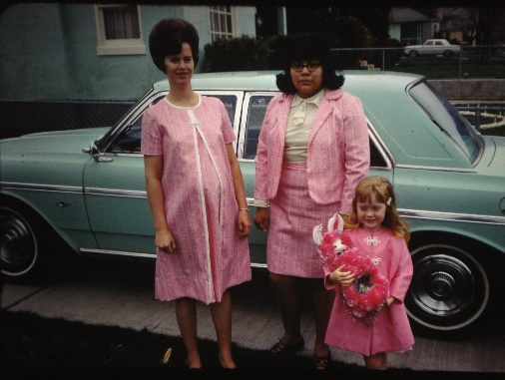 **LARINA TAVO** - When I was about five months along, the church again asked for families to take in foster Indian children. Ken felt we should do it again, but I wasn't certain since I was pregnant. I wasn't sure I wanted the responsibility of another child right then. I talked to my mother and she felt I shouldn't take the chance of bringing more stress into my life and maybe causing another miscarriage. Ken & I prayed about it and Ken still felt strongly that we should do it. I felt ok about it - so we did. Again, we had taken too long to decide and they told us that it was too late, but if a child didn't work out in a family, which sometimes happens, then they would need to place them in another home and wondered if we would be willing to take one then. Ken said we would. About two weeks before Christmas, they called us saying they had a 15-year-old girl, **Larina Tavo**, who wasn't working out with the foster family she was with and would we take her? I was worried that if she wasn't working out with that family, would she work out with us? I wasn't really excited about it, but we took her. Mom was worried about us taking her also, for fear it would cause stress and cause another miscarriage. Larina turned out to be a cute girl, although very overweight. I enjoyed her personality and we got along good. We found out, from the caseworker, that the reason she hadn’t worked out in the other home is because the mother was going through the change of life and having a hard time. This made her ornery and she treated Larina like a slave and took out her frustrations on Larina. Larina finally called her caseworker and told this lady that she wanted to go home. She talked Larina into trying another family, and we were the other family. It was hard when she would go home each summer because she would go back to her old ways and when she would come back to us each fall, we had to start over again as far as hygiene, manners, etc. She was such a large girl that we could only buy her clothes in the "big" women's sections of the stores. These didn't look like a teenage girl, so I would make her clothes. She looked a lot cuter. She liked the clothes and really acted like she appreciated me making them for her. Larina had a bubbly personality so most of the time I rally enjoyed her. She had a lot of problems so she was a challenge also. Her grooming habits were bad and she had an odor, which we tried to help her with. We also tried to help her with her weight. We took her to a doctor and he put her on a diet, but she wouldn’t stick to it. In fact, she ate so much that when she went home in the summers, our food budget would cut almost in half. She would offer to gather up the dishes and then she would eat any food that was left on the table. She would also take food and hide it under her bed to eat later at night. Larina would confide in me and we had many good talks. She was usually good to baby sit Sandy for us and the other children as they came along. She helped me with the housework although not too willingly some times. But, of course, most children have this problem. She went to church regularly with us and enjoyed and participated in family home evening. For the most part, I really enjoyed Larina, and I am 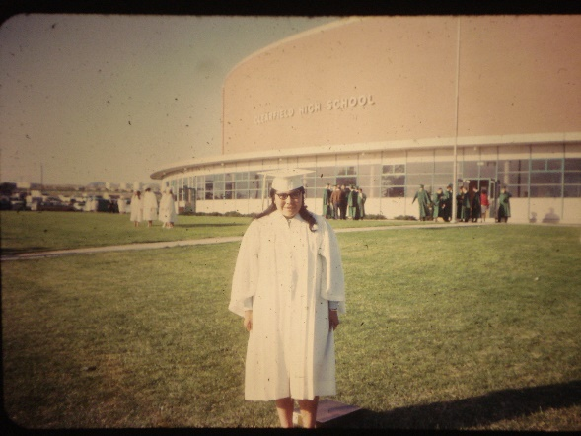thankful that we had her and for that experience**. She lived with us until she graduated from Clearfield High School - so 3 ½ years.** Her best friend was Debbie Higley. Debbie was our favorite babysitter, when we lived I Clearfield. Debbie would drop other plans when we called to see if she could babysit our children. Her loved us and our kids and we all loved her. I really missed Larina after she graduated and went back to Fort Hall, Idaho. She could have had a good opportunity to go to college or trade school as the tribal council would give these school graduates an aptitude test and then pay for their board, room and college expenses for them. But, instead she met an Indian guy who was ten years older than her and had been married before. She married him and had a baby girl. She realized the mistake she had made as he was always getting drunk and betting her up so she finally had him put in jail and divorced him. She remarried and had three more children and then had problems with him so left him and the children for a time. She started drinking and ended up in the Salt Lake Rehabilitation Center. She found that we were living in Taylorsville so called us and we came to get her and kept her for the weekend, but then we had to take her back. While she was there, she started working for them as their cook. We called each other a few times while she was there and brought her out another time for dinner. We went to see her on Christmas Eve and took her a gift.

After we moved to Erda, we didn’t hear from her again until several years later. Her mother had died and she was feeling really bad. She found Mom & Dad’s phone number and called them to get our phone number. I think we were living in Grantsville at the time. She said she would like to come see us. I told her we would like that too, but to let us know when she was coming so we would be sure to be home. I don’t know whether I didn’t sound excited enough or what, but she didn’t come and I didn’t hear from her again. I tried to look her up, but didn’t have any success. Irvin, Ken’s younger brother, said he saw her scrounging through garbage cans with some other drunken Indians. She recognized him and came over to talk to him. He said she looked awful and reeked with alcohol. She wanted our phone number, but he didn’t give it to her as he was afraid she would just wanted it so she could play on our sympathy and we would give her money, etc. He didn’t think that would help her. I really feel bad that she messed up her life when she had a chance of making something of it, but I also realize that with the Indians, they are like crabs who are put in a bucket and if one tries to get out, the others pull it back in. It’s hard for the Indian people to break out of their environment and succeed in life. **In 2000, I think it was, Larina found our phone number** (we had no idea where she was, so couldn’t find her) and called us. She had married again and this guy was good to her. They were coming with some of her relatives to Layton and wondered if we could meet her and her husband in the lobby of the motel they would be staying in. We were excited to see her again and to meet her husband. We met the rest of her family and then they left, except for Larina and her husband and we had a good visit and caught up on her life and told her about our life. Her oldest daughter had died and she was sad about that. Larina has had lots of problems throughout her life, but I just wonder what her life would have been like if she had been able to stay true to the gospel, gone to college and met a good man and raised a good family. I’m sure she and her family would have been much happier. I haven’t heard from her since.

**I will tell a couple of incidents we had with her**. One was when she came back to us for her junior year. She had found a boyfriend over the summer and didn't want to leave him. Her parents and the caseworker had told her she had to - so she had come against her will. She was not corporative and was moody and ornery. Finally, we called the case worker and told him to come get her - that if she didn't want to be here, we didn't want her here either. He came and had a long talk with her and convinced her that this was a wonderful opportunity for her and she might mess up her life if she went back home. Larina had come from the Indian reservation by Blackfoot, Idaho. She straightened up and we enjoyed her.

We didn't overwork Larina, but we expected her to help out, just like we would our own children. One day she came home from school and I asked her to do something. She looked at me with a frown and said "What have you been doing all day today?" That really upset me, as I have always worked hard. I said "I've been sitting in front of the TV watching soap operas, smoking and drinking beer". That really shocked her (it shocked me too that those words came out of my mouth) and she knew I was angry at her for asking such a question as that, and she never dared ask me that again.

One time when Ken & I were going on a little weekend vacation with some friends, we asked Ken's Mom if she would watch the children. We were living in Clearfield at this time. Larina didn't have a driver's license, but we had gone with our friends and left the car at home. Ken's Mom was taking the children to church and Larina told her that she wasn't feeling well so didn't go with them. Larina had a friend in Ogden (Marianne) that she became close to when we lived them. After Ken's mom & the children went to church, she called her friend and told her she would drive over to see her. She took our car, drove to the friend's house and then they proceeded to go for a joy ride. She noticed the car was about out of gas so they stopped at a gas station. She didn't judge right and ran into the gas tank. The owner called the police and when they found out Larina didn't have a driver's license, they thought she had stolen the car and took her to jail. When we got home Monday morning, Ken's mother told us the story and Ken went to get her out of jail. She had spent the night there with a lady who had epileptic fits and another lady who murdered her husband. When Ken got Larina, she was white as a ghost. She was so scared. Ken had to go to court with her and he told the judge that she was our foster daughter and it was our car and he was not pressing charges - so they let her off. It scared her bad enough that she never tried taking the car again, and she never even asked to do so.

When I was pregnant with Shellie, I not only would throw up, but I would pass out and throw up at the same time. It really scared Ken, but the doctor explained that with some pregnancies, some women did that. I hadn't with Sandi. The first time it happened, after Larina came to live with us, she was really scared and started to call the ambulance when I came out of it and told her I was all right. I would feel like I had to throw up so would run to the bathroom, then I would feel like I was going to pass out - and that's right, I did both of them. It was awful, but it didn't happen with any other pregnancy, thank goodness. (I have covered everything about Larina here in this part of my history. Now I’ll go back in time again.)

**Soon after Shellie was born, Dr. Close had a heart attack and died**. He overworked himself - he couldn't turn people away and since his office was in his home, people came at all hours of the day and night. I was worried that since he had died, maybe I wouldn't be able to have more children other than Sandi and Shellie. But, whatever Dr. Close fixed, he fixed good and I never had problems getting pregnant after that. I did have more miscarriages, but we were able to have six wonderful children, plus our little "Amy" who died due to water on the brain when I was seven months along. I will tell about this later on.